**EXPERIMENT-10**

**MAKING COMPUTER LAB IN CISCO PACKET TRACER**

**Aim:** Making Computer Lab in Cisco Packet Tracer.

**Software / Apparatus required:** Packet Tracer / End devices, Switches,

connectors.

**Procedure:**

**Step 1**: Launch Cisco Packet Tracer and create a new project.

**Step 2:** Select the appropriate network devices for your lab. In this case, you will need

computers, switches, and routers. You can find these devices in the "End Devices," "Switches,"

and "Routers" sections of the device list.

**Step 3:** Drag and drop a switch onto the workspace area. Connect the switch to the power source

by clicking on the "Connection" option and selecting "Power."

**Step 4:** Connect computers to the switch by dragging and dropping them onto the workspace

area. Click on the "Connection" option and select "Fast Ethernet" to connect the computers to

the switch.

**Step 5:** Repeat Step 4 to add more computers to the lab. You can adjust the number of

computers as per your requirements.

**Step 6:** Connect the switch to a router. Drag and drop a router onto the workspace area and

connect it to the switch using a serial cable. To do this, click on the "Connection" option, select

"Serial," and then select the appropriate serial interface on the router.

**Step 7**: Configure IP addresses on the computers. Select a computer, click on the "Desktop"

tab in the device configuration panel, and configure the IP address, subnet mask, and default

gateway for each computer.

**Step 8:** Configure IP addresses on the router interfaces. Select the router, click on the "CLI"

tab in the device configuration panel, and enter the interface configuration mode. Assign IP

addresses to the router interfaces connected to the switch and computers.

**Step 9:** Test connectivity. Open the command prompt on each computer and try to ping other

computers and the router's interfaces to ensure connectivity.

**Step 10:** Customize and expand the lab as desired. You can add additional devices, configure

VLANs, implement security measures, or set up servers within the lab environment.

**Diagram:**

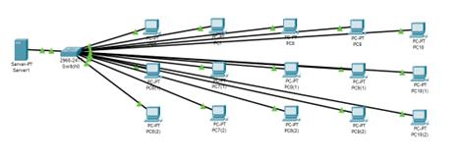

**Output:**

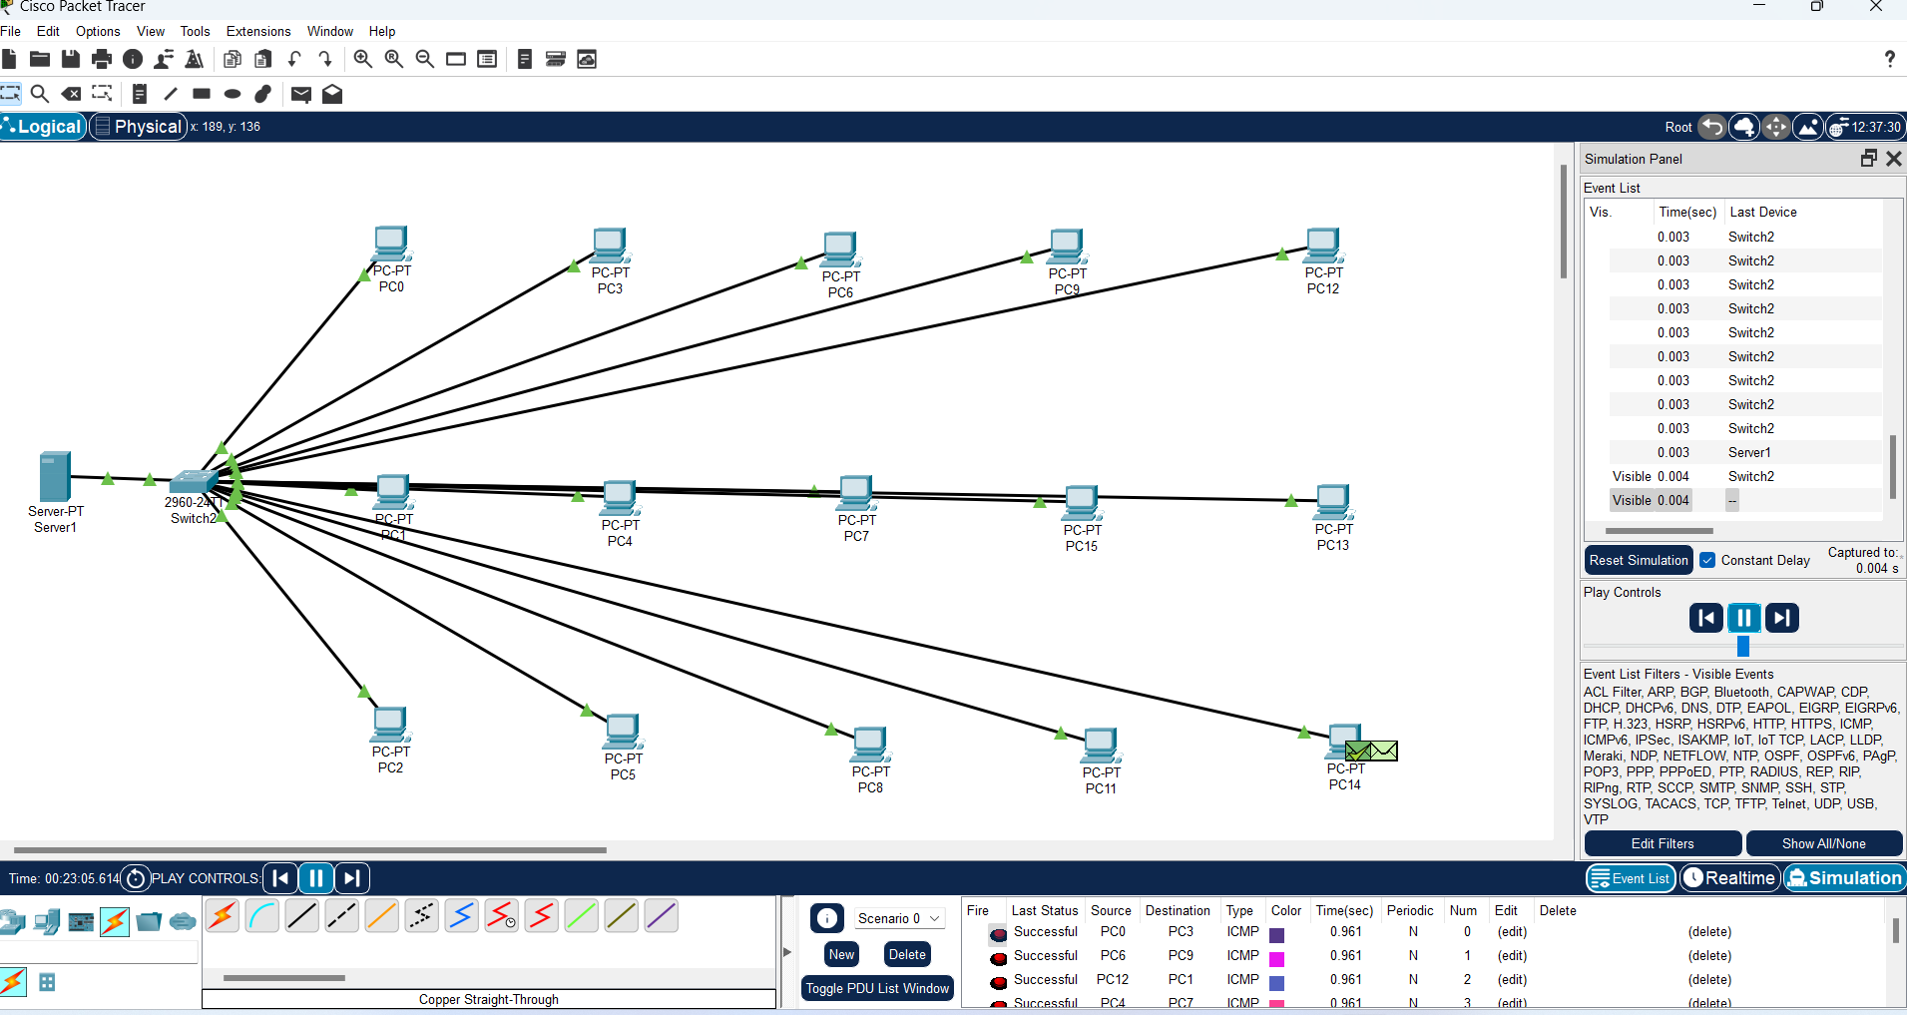

**Result**: Thus the Computer Lab in Cisco Packet Tracer is set up successfully